**Case study exercise:**

***Drugs policy***

**Time allowed: 45 minutes**

**Assignment**

**Important notice**

**This document presents a fictitious scenario. It has been produced solely for the purpose of this exercise. All references to existing countries, international organisations, private companies, departments and their representatives, etc. have been invented purely as examples. Any views expressed should not be taken to represent the opinions of those bodies or persons. When dealing with this assignment, participants should therefore rely solely on the information presented in the exercise and not on any prior expertise in the field.**

For this exercise, you will take on the role of Bim, an Administrator in the Communications Unit of the European Commission's Law and Order Department. All the necessary information is provided. It comprises a number of emails, reports and other documents that you will have to analyse in order to be able to deal properly with the assignment given to you. This is your first day at your new job.

It is important that you accept the scenario as it is presented. Although in real life you would have access to other sources of information and would be able to consult your colleagues, in this exercise you are limited to the information provided. You are, however, allowed to make logical assumptions where information is missing or incomplete.

This case study is designed to assess the following competency: Communication. No previous knowledge is required to deal with the assignment.

Your task will be to present solutions to a number of problems based on the information given by various parties (and available for you to read in the following pages). On the day of the test, you will be given a specific task and then 45 minutes to take the test. Make sure you explain the reasoning behind your ideas and include all the information on which you wish to be evaluated.

Please note that it is strictly prohibited to refer to any notes you have prepared in advance or to take notes during the test.

**Please note:**

**today is Tuesday 20 March 20XX**

**Last year was 20XX-1, next year will be 20XX+1**

**Abbreviations**

**Abbreviations used**

| Commission | European Commission |
| --- | --- |
| EU | European Union |
| Europol | EU Agency for Law Enforcement Cooperation |
| LOD | Law and Order Department (European Commission) |
| MEP | Member of European Parliament |
| UN | United Nations |
|  |  |

**Background**

**Background information**

The Commissioner of Law and Order, Mr Georg Thompson, launched the so-called “war on drugs” in 20XX-2. This is a flagship policy initiative within the framework of the overall EU Drugs Strategy. The “war on drugs” focuses on curbing supply, both import into Europe and production within the EU. The overall Drugs Strategy also includes other elements such as mitigation of harmful effects of drugs, and research/innovation initiatives.

The war on drugs includes more active cooperation and collaboration between the EU institutions: the Law and Order Council of Ministers, the Commission, Europol and the new EU Drugs Agency.

The Drugs Agency was created on 1 January 20XX by reorganising and reshaping the former EU Drugs Monitoring Centre. The objective was to strengthen the mandate of the centre and give it a more active role in implementing the Drugs Strategy. The monitoring centre has been a highly appreciated expert hub with a good track record.

The EU also cooperates on these issues with international networks such as Interpol (The International Criminal Police Organization comprising 194 member countries) and the UN Drugs and Crime Office.

**Welcome e-mail**



**LOD**

| Subject: Welcome!  From: Julie Poirot, Manager, Communications Unit, LOD  To: Bim, Administrator, Communications Unit, LOD  Date: 20 March 20XX, 09:00  Dear Bim,  Welcome to the team.  You join on a most exciting day - you will soon hear the news about a very successful raid against drug traders. It took place over night and simultaneously in several Member States, with more than 200 suspects taken into custody by the national police forces. This was all thanks to long and hard intelligence work by Europol. We will have to act very fast now to decide whether Commissioner Georg Thompson should take part in the midday briefing today, commenting on the raid. I also forward a **confidential** e-mail with more information about the next steps on the operation as you will be working with me on this.  In the slightly longer term, our LOD Director Mr Klubíčko will need to visit the new EU Drugs Agency in the coming weeks. You will be involved in the preparations of his meeting there.  And finally, the mid-term evaluation of the EU Drugs Strategy will be completed this spring. We need to take stock of the progress so far. It is also an opportunity to look forward and, if needed, adjust our set of actions for the second half of the strategy period. Commissioner Thompson has asked for new proposed measures to be put in place to further strengthen the ongoing “war on drugs”.  As you can see, you will be quite busy! Please start reading the background materials as quickly as you can.  Kind regards,  Julie |
| --- |

**Question from MEP**

**Written question: war on drugs**

Question for written answer W-000047/20XX

to the Commission

MEP Andrea Montalbano

Submitted: 9 March 20XX

The so-called War on Drugs is not going well. The Commission and Europol keep bragging about their great success in cutting supplies, but reality says differently. Criminal organisations shoot innocent bystanders on our streets. Just last week, a young mother was shot in Savoria, because she got in between two warring gangs by accident. How much longer should we have to suffer the consequences of the old-fashioned legal framework that gives organised crime this profitable market opportunity? Citizens of Europe want to relax and have fun. They will not stop drinking wine or smoking a joint on a Saturday night - and they should not have to. The police should spend less time chasing innocent, occasional users of currently “illegal” substances. They should instead focus all their resources and efforts on the actual culprits: the gangs and the terrorists.

Keeping substances such as cannabis illegal plays right in the hands of the gangs. Legalisation would take away that market, as the organised crime syndicates are unlikely to start selling openly in lawful shops with proper taxation and authority control.

For the sake of protecting the citizens, for using law enforcement resources more efficiently and for creating a more safe and just society, it is time that we let go of old prejudice about what “drug” can be legal and what cannot. Today the arbitrarily set line goes between a vodka shot and a cannabis vape. Tomorrow it should rather go between the harmless social drugs and the substances scientifically confirmed to actually be dangerous, such as heroin.

1. Does the Commission not see benefits from legalising drugs in the EU?

2. What actions does the Commission intend to take to increase the effectiveness of enforcement actions and cross-border cooperation to stop organised crime?

**E-mail 1**



**EU Drugs Agency**

| Subject: Invitation  From: Henny Wallander, EU Drugs Agency  To: Emil Klubíčko, Director, LOD  Cc: Julie Poirot, Manager, Communications Unit, LOD  Date: 14 March 20XX  Dear Mr Klubíčko,  I would like to invite you to come and visit the EU Drugs Agency now that the transition to the new organisation has been completed and the dust starts to settle. We would very much appreciate your support and your presence to address the staff. You could also have a series of face-to-face meetings with the agency managers.  As you know, the reorganisation has been quite challenging. Many in the team have strong feelings about our new way of working and the new office set-up. I fear there are some misunderstandings about the Commission’s purpose and process that we would need to straighten out. Your participation in a town hall meeting with the staff in April would send a strong signal about the Commission’s goodwill and interest in improved relations with the agency. It would also send a message about the unity between Commission and agency management.  I also take the opportunity to raise again our proposal to boost the work strand on information exchanges among Member State law enforcement bodies. We consider this a low-cost and nothing to lose option that we could start working on immediately. Drawing from each others’ experience is always useful. Please consider this for the second half of the Drugs Strategy implementation.  Kind regards,  Henny Wallander  Henny Wallander  Manager  EU Drugs Agency |
| --- |

**E-mail 2**



**Europol**

| **CONFIDENTIAL AND ENCRYPTED**  Subject: Heads-up about operation Cola Zero ready to go  From: Zygmunt Szacki, Manager, Europol  To: Emil Klubíčko, Director, LOD; Julie Poirot, Manager, Communications Unit, LOD  Date: 16 March 20XX  Dear Emil and Julie,  Just letting you know that we have a go-date for operation Cola Zero, overnight between 19 and 20 March. Please be ready for media requests and potential statements by the Commissioner in support of Europol the day after. I expect quite a lot of media interest, as usual.  In addition, the second and much bigger step of the operation is also at countdown. The date is set for 2-3 weeks from now. You will receive more details when we get closer. Please be reminded that this information must not go further and can only be shared with those members of your team who will be working actively on preparing the communication aspects.  We keep in touch,  Zygmunt |
| --- |

**E-mail 3**

| Subject: An offer you can't refuse  From: Raymond Marlowe  To: Georg Thompson, European Commissioner for Law and Order  Date: 26 February 20XX  Dear Commissioner Thompson,  On my Europe tour promoting my new book “Stopping the Mafia - Yes, It Is Possible”, I will pass through both Brussels and the Hague.  I know we share the same ambition of a world free of drugs, terror and crime organisations. I therefore offer my services. I would be happy to give a lecture to your EU anti-drugs experts and Europol network, for free! I’d even sell my book at half-price to the audience, signed and all. I believe that the latest discoveries on my side of the Atlantic will revolutionize the work of EU law and order.  I’ll bring an entire toolbox of fresh ideas and inspiration to your team. In the state of Pinnatassee, one of the worst affected states in the southeast North Americas, crystal meth sales and related public health costs went down by 25% in only two years using my methodology. A key step is to get the general public involved in the hunt for the gang leaders! The bad guys should have nowhere to hide. They should always be afraid that the local hairdresser or little old lady across the street might recognize them and turn them in.  My personal assistant will help you coordinate a date during my tour.  Looking forward to hearing from you,  Raymond Marlowe, Ph.D. |
| --- |

**Website 1**

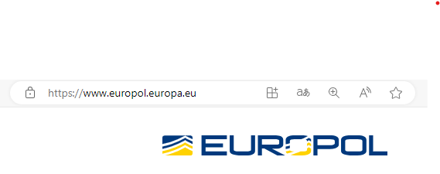

**About Europol**

Headquartered in The Hague, the Netherlands, Europol’s mission is to support its Member States in preventing and combating all forms of serious international and organised crime, cybercrime and terrorism.

Large-scale criminal and terrorist networks pose a significant threat to the internal security of the EU and to the safety and livelihood of its people. The biggest security threats come from:

* terrorism;
* international drug trafficking and money laundering;
* organised fraud;
* the counterfeiting of euros;
* trafficking in human beings.

Europol supports investigations initiated by Member States, though Europol officers never arrest citizens or instigate investigations. Europol’s work usually consists of dealing with crimes that require an international approach and cooperation between several countries, inside and outside the EU.

**Facts and figures**

* More than 1400 staff
* 264 Europol Liaison Officers
* Thousands of international investigations supported each year
* Became an official EU agency on 1 January 20XX-12

**Our work**

Our position at the heart of European security architecture allows us to offer a unique range of services. Europol is a high-security operational centre that operates non-stop: 24 hours a day, seven days a week.

Analysis is at the core of our activities. Our criminal analysts are among the best trained in Europe. They use state-of-the-art tools to support investigations by law enforcement in Member States on a daily basis.

Europol is accountable at the EU level to the Council of Ministers for Law and Order Affairs. Its partner organisations include the EU Drugs Agency and Interpol. Europol also supports drug raids by offering criminal intelligence analysis and operational support to law enforcement.

**Minutes 1**



**LOD**

**Meeting minutes: LOD senior management meeting**

| Date | 9 November 20XX-1 |
| --- | --- |
| Attendees | Managers of   * the Drugs Strategy Unit, * the Organised Crime Unit, * the Legal Advice Unit, * the Budget and Human Resources Unit and * the Communications Unit. |
| Topics | Legalisation proposal, Agency reorganisation, information exchanges |

| 1. Legalisation debate |
| --- |
| * The pressure is again up on EU-wide legalisation of certain so-called social drugs, e.g. cannabis. A group of around 20 Members of European Parliament (MEPs) under initiative of MEP Montalbano recently had a public event about it, receiving much positive attention. * The issue is very complicated and especially the use and abuse of prescription drugs creates a new type of grey zone and uncertainty. The Commission needs to find a balanced compromise position. * A main argument from those advocating legalisation is the need to take away an income source from organised crime. |
| 1. Agency reorganisation |
| * All is now ready for the transition of the Drugs Monitoring Centre into an EU agency on 1 January 20XX. * The Budget and Human Resources Unit reported that all new managers have undergone both interviews and competitive tests to be appointed or reappointed in their new positions. With the new and slimmer organisation, fewer managers were needed and some of the old management set have been offered positions in other agencies or have opted to voluntarily change to senior expert titles. The organigramme and new appointments will be published shortly. * The results of the extensive staff and stakeholder consultation on the new organigramme were shared. |
| 1. Engaging more exchange of experience |
| * More information exchanges seem to be needed among national police authorities. The latest Europol report shows that enforcement methods and success rates vary widely from country to country. * The Drugs Strategy Unit was asked to think about creative new ways to encourage more exchange of experience and lessons learned. The Unit was asked to report back in the new year. |

**E-mail 4**



**EU Drugs Agency**

| Subject: Action ideas  From: Henny Wallander, EU Drugs Agency  To: Julie Poirot, Manager, Communications Unit, LOD; Zygmunt Szacki, Manager, Europol  Date: 5 March 20XX  Dear Zygmunt and Julie,  Some ideas for the mid-term evaluation of the Drugs Strategy - and more importantly, for further action in the coming years.  What we really see as missing is the *demand side*. We are good at chasing the supply side but much more can be done to cut the demand by consumers. The various legalisation campaigns have been very successful in sending the message that drugs are nearly harmless and should not be seen as something shameful or wrong. We see the result in an ever increasing demand for illicit drugs.  We want more information campaigns to draw people’s attention to the links between the party drugs they consume and the power base of the organised crime networks. We also need to tackle demand via the medical profession and awareness-raising among doctors and nurses regarding prescriptions of potentially addictive substances including opioids. On both these issues, the Drugs Agency would be ready to help and support implementation.  More can also be done to follow the money trail. Mapping and confiscating drug profits means reducing the power basis for organised crime. The current mandate of Europol could be extended, allowing for a more active role in EU-wide financial investigations. This type of intelligence work is Europol’s strength and something that needs to be further developed.  As the new detection and tracking/testing tools have been such a success, perhaps also invest more in research and innovation of such new methodologies?  Kind regards,  Henny Wallander  Henny Wallander  Manager  EU Drugs Agency |
| --- |

**News article 1**

**News Today**

Date: 5 March 20XX

# To ban or not to ban

Nobody in Brussels has missed the ongoing campaign for legalising so-called “party drugs”, led by MEP Montalbano. The recent stunt of smoking a joint in plenary caused quite an uproar in the more traditionally minded circles. However, the popular support, especially among the young, seems high.

But what is really at stake here? *News Today* asked health expert Simone Maigret, Professor at the Benedict Medical University in Savoria.

Professor Maigret points to the example of cannabis, the most widely used illicit drug in Europe. It is used mainly by young adults. “Cannabis use is often experimental, commonly lasting for only a short period of time in early adulthood. This might not seem like a major problem. However, a minority of people develop a stronger addiction followed by very serious problems, including physical and mental health issues. This leads to poor performance at school or work, in turn leading to social and economic problems for the individual”, says Professor Maigret. “The laws concerning cannabis need to remain in place to protect those most vulnerable people.”

One consequence of strict legislation is that these young experimenting people risk incurring criminal records for use or possession offences. This is seen by many as a disproportionate penalty to the actual harm caused by cannabis use. Legalisation would reduce that problem.

Professor Maigret also sees another potential benefit to a law change. There is today an ever-growing range of new products put on the market: capsules, oils, candies and vaporisers. These each bring different new risks, such as overdoses, lung injuries and increased risk of cancer. By legalising the use, regulations could be put in place on the content and quality of such products.

However, there are strong disadvantages too. The social acceptance of drugs is often quoted. While somewhat controlling the supply, legalisation has shown to increase the overall demand and use, legal and illegal alike. Occasional users are expected to turn into regular users at a much higher rate. Legalisation could also lead to an increase of very young consumers. These are affected worse by the negative side-effects, notably with impacts on their cognitive functions.

Henny Wallander of the EU Drugs Agency comments: “legalising party drugs is a popular proposal, but it is not very efficient as a means to get at the core problems: public health, protection of the most vulnerable segments of society and reduced crime and violence”.

**E-mail 5**



**LOD**

| Subject: Legal assessment for the mid-term evaluation  From: Frederic Adamsberg, Administrator, Legal Advice Unit, LOD  To: Julie Poirot, Manager, Communications Unit, LOD; Petra Verhoeven, Administrator, Drugs Strategy Unit, LOD  Date: 29 February 20XX  Dear both,  Let me just remind you about the private data protection challenges of the “most wanted” campaign done some year ago. With the new and stricter rules, this kind of activity is getting more difficult.  I know the Drugs Agency experts got very excited about the report this summer, proposing that they could take over all liaison with the UN Drugs and Crime Office. Budget-wise it is a good idea but from the overall policy perspective, I would advise against it. Policy steering of the cooperation with international bodies such as the UN offices should remain with the Commission. The agency does not have the same level of accountability or mandate to negotiate on such sensitive matters.  The Expert Group on Law and Order met last week. One of the main messages from national police representatives was a general reluctance to engage in further exchange of best practices. They feel they have had little else in the past couple of years and that it hasn’t yielded measurable results. The experiment with a shared-document platform for informing each other about lessons learned was a big failure with one single fiche uploaded by one Member State since the start of the Drugs Strategy period. The majority of participants asked instead for more legal action and hands-on support, e.g. cross-border information gathering and tracking of financial transactions.  Let me know if you have any questions on this.  /Frederic |
| --- |

**Blog post 1**

| **ON THE BEAT**  *Blogged by Pepe Carvalho*  *Former police officer*  *45 years in the force*  *Vast experience on organised crime*  **The Marlowe doctrine**  *6 March 20XX*  Dear blog readers,  I see that North American crime expert Raymond Marlowe is going on another book tour! If only I could produce books at the same speed he does, I could really use that extra cash.  Marlowe is an interesting figure. I’m not saying he’s altogether wrong but his methods are very much questionable. He does not seem to care about the negative side effects of his work. I’m thinking for example of the lack of witness protection and the high number of revenge killings following his Pinnatassee informer state experiment. His methods are simply not adapted to the EU reality and our legal systems.  I really hope someone will dare question this self-appointed guru on his preaching tour. When forced into a debate with a knowledgeable counterpart, I have heard him stop the empty phrases sales pitch and deliver some quite interesting thoughts. Mostly though, I find him a very loud chatterbox.  Speaking about chatterboxes, the honourable MEP Montalbano is at it again too! Well, if people like you, dear MEP, could just refrain from smoking cannabis in front of the TV cameras, maybe that would help reduce the power and influence of the gangs too. Have you thought about that?  I’ve said it before and I’ll say it again: reducing supply is good, reducing demand is equally important. We need to persuade people to change their habits. People today drink less alcohol and eat less red meat. Surely, they will also be ready to take less drugs if they understand the consequences?  When I was still in active service, I spent lots of time talking to young people about their life choices. Many of them had no idea about the actual societal costs of their drug habits. This type of lesson learned should be spread more. I’m ready to go on a speaking tour on this and I promise you, my fee is much more modest than that of Dr Marlowe. |
| --- |

**Report**



**LOD**

**LOD budget and expenditure review**

Date: 15 July 20XX-1

**Half-time review of LOD budget and expenditure in 20XX-1 and preparations for budget proposal for 20XX**

1. **Contracts and consultancy**

Almost 48% of the annual budget for externally procured services has been committed so far. Units are encouraged to finalise the outstanding contracting processes within the coming 3 months to ensure contract signatures in time before the end of the calendar year.

1. **Travel funding**

The new restrictive policy of fewer trips abroad has delivered savings of 12% compared to the travel expenses for 20XX-2.

A main cost is the travel to international fora and meetings including with the UN bodies. The LOD senior management could consider further reducing such costs by shifting the full responsibility for all liaison with e.g. the UN Drugs and Crime Office to the EU monitoring centre (to become the new EU Drugs Agency). Today, experts from both the Commission and the monitoring centre travel to Geneva three times per year. The monitoring centre assumedly will have enough expertise to manage in Geneva on its own once it has been transformed into a full agency.

1. **Staff resources**

Two more posts will be granted to the Communications Unit. The Legal Advice Unit will need to cut away one staff post. Units are reminded about the need to use scarce resources prudently.

1. **Savings from the agencies**

The reorganisation of the monitoring centre into an agency will result in savings of 9% of staff costs, thanks to a slimmed down personnel structure and a further 32% savings in reduced office costs. The new smaller office space will be more efficiently used as an open office landscape with modern “hot-desking” (that no staff members have their own seat but colleagues choose a random desk upon arrival to the office). This change is much appreciated by the agency staff as the update will be accompanied by more flexible telework rules and possibility for colleagues to work 40-60% of their time from home.

**Minutes 2**



**LOD**

**Meeting minutes: LOD senior management meeting**

| Date | 8 March 20XX |
| --- | --- |
| Attendees | Managers of   * the Drugs Strategy Unit, * the Organised Crime Unit, * the Human Trafficking Unit, * the Legal Advice Unit and * the Communications Unit. |
| Topics | Mid-term evaluation, communications strategy, external speaker invitations |

| 1. Mid-term evaluation of the EU Drugs Strategy |
| --- |
| * The mid-term evaluation of the strategy, including the flagship action “war on drugs” as coined by the Commissioner, is under way. You received a summary of indicative results earlier this morning from the Drugs Strategy Unit. * In addition, Europol reports an overall success rate above targets in shipments stopped at port. This is due to good cooperation between national port authorities, national police and the coordination efforts by Europol. * Still, the drug import is thriving and continues to expand fast into trade in opioids. A problem with the EU Strategy target setting is that organised crime changes faster and more flexibly than EU policy instruments can be revised and adapted. Our targets tend to be out-dated already before they can be followed-up and monitored. |
| 1. Drugs Agency and Europol joint communications strategy |
| * Europol and the Drugs Agency have expressed wishes for more joint communication and PR campaigns. Both Directors want more explicit promotion of their respective agencies by the Commissioner. * The Communications Unit reminded about the difficulties in agreeing on shared messages to go out to the media quickly enough on urgent issues. It was agreed that items with long-term planning could be better coordinated with the agencies. * The results of the mid-term evaluation of the Drugs Strategy could be an example. |
| 1. Invitation of external speakers: offer by Raymond Marlowe |
| * The staff committee has expressed a wish to accept the offer by North American speaker Raymond Marlowe for an inspirational lunch-time event. * It was proposed that a wider audience could be considered for sharing the potentially new insights by Dr Marlowe. For example, national Expert Group members from the Member State police authorities could be invited to listen in via video link. * The legal advisor recommended not to accept sales of Dr Marlowe's book on Commission premises. |

**News article 2**

**News Today**

Date: 4 February 20XX

# Criminal networks an increasing threat to us all

The amount of shootings and gang-related violence in Europe has never been as high as during January this year. Warfare between competing organised crime networks has started to affect innocent bystanders at quite alarming rates.

Europol is mapping and analysing the trends among criminal networks. They conclude that it is mainly a battle for control over local drug markets. What used to be internal shoot-outs is now taken to the streets, with “collateral damage” among ordinary people who simply happen to be at the wrong place at the wrong time.

Zygmunt Szacki, Europol veteran said: “The escalation we see now is linked to the higher profits and the amount of power the gangs can derive from the drugs sale. The demand is growing and they find consumers in every social group. However, the drug sales are only a small part of it”.

It seems, the criminal networks today have diversified from their traditional business models of human trafficking, narcotics and weapons. Today, their financial schemes involve a mix of legal, semi-legal and illegal activities, constantly moving money from one part of the organisation to another. Public procurement deals and financial fraud have become central pillars of many crime networks, creating bigger turnover than the drugs sales - and with less risk involved.

Should the general public be worried? Zygmunt Szacki replies: “Yes, there is cause for worry. These individuals are getting reckless and ruthless with little respect for human life. The EU and Member State authorities will need to step up the work to track them and bring them to justice. For this fight against crime to be successful, we need more resources for the police, at all levels - and quickly”.

**Internal discussion forum**

**EU Drugs Agency - online staff forum**

| 2 March 20XX  09.41 | **< User: Jane>**  It happens again! I arrive at the office and there is no available desk for me. The new hot-desking system does not work. Now I’m sitting in the canteen working on my laptop and waiting for a desk to be available. Useless! |
| --- | --- |
| 2 March 20XX  09.56 | **< User: Anne>**  @Jane: Get to the office earlier, I arrive at 07.30 and I always get the desk I want. |
| 2 March 20XX  10.14 | **< User: Jane>**  @Anne: Haha. Very funny. It doesn’t solve the problem, it just means another colleague has to sit in the canteen or in the copy machine room or wherever they find a place to sit. We need more office space. |
| 2 March 20XX  11:35 | **< User: Peter>**  Hear hear! The open office landscape solution is no good. It’s just cheap. The Commission doesn’t care about us in the Agency. The only good thing is the telework flexibility, it’s great to be able to work from home more often. |
| 2 March 20XX  12:03 | **< User: Dirk>**  I thought the reorganisation was supposed to make our mandate stronger but from what I see, it was mostly a staff cut and a way to get rid of all the really good managers. I don’t know how they selected the managers to stay but it smells like corruption to me. |
| 2 March 20XX  12:32 | **< User: Anne>**  I’m going for lunch now, see you in the canteen? 😀 |
| 2 March 20XX  14:07 | **< User: Augusta>**  It’s not just the selection of managers - we’re all upset about that - but also the general feeling of being seen and treated as second-rate EU employees. We never get any publicity either, it’s always just Europol getting all the credit for the work we do. I thought it would change when we were “upgraded” to a full-fledged Agency but I see no difference. We’re not even allowed to take over the UN Drugs and Crime Office liaison yet. We’re doing all the work on it anyway. |
| 2 March 20XX  14:49 | **< User: Dirk>**  Did you hear that Raymond Marlowe might be coming to Brussels to give a lecture for the Law and Order Department colleagues? I hope they invite us too! |
| 2 March 20XX  15:38 | **< User: Jane>**  I don’t like him, he’s so full of himself. It would be nice to be invited to those policy lunch talks sometimes though, it could be useful for us too. |
| 2 March 20XX  17:12 | **< User: Augusta>**  As if that would happen. I’m sure the Commission thinks it’s too expensive to invite the unimportant Agency crowd… |

**E-mail 6**



**Europol**

| Subject: Re: Action ideas  From: Zygmunt Szacki, Manager, Europol; Henny Wallander, EU Drugs Agency  To: Julie Poirot, Manager, Communications Unit, LOD  Date: 7 March 20XX  Dear Henny,  Thanks for your e-mail.  I’m not so much in favour of your financial investigations idea. It is not in our current mandate to *initiate* investigations. To change that would require a complete new decision procedure amending the Europol set-up. Would it really be worthwhile? We already do plenty in this area. To expand our scope, we would need more resources and recruit more experts on finances and taxations schemes. Those experts mostly work at the national level today and I don’t see an urgent need to change that. Rather, the EU Drugs Agency with all its new resources should develop capacity to support Europol in this and other work.  However, I couldn’t agree more about the ridiculous campaigns in favour of legalising drugs. The Commission needs to take a much more clear stand on this. I have some doubts about the efficiency of any information campaign though. In my opinion, people tend not to take EU campaigns very seriously. Rather, this should be a police enforcement matter, getting more users to face legal consequences. Stricter penalties EU-wide would be useful. Fines from drug users could cover the added costs for more law enforcers in the Member States.  If there is any information campaign done - I know the Commission is always keen on those - the most important thing is to give due credit to Europol and the Drugs Agency for the work we do. We deliver most of the groundwork but we never get any visibility and praise for our efforts. It’s always the political level and the Commissioner who gets all attention.  My two cents on this,  Zygmunt |
| --- |

**Blog post 2**

| ⭐⭐⭐ *In service of the people* ⭐⭐⭐ |
| --- |
| Andrea Montalbano  MEP, blogger, EU citizen  **Don't blame the users**  *29 September 20XX-1*  I know that I’m often caricatured as a crazy person. I’m sure this is how Copernicus felt too, telling a truth that was not appreciated at that time.  I’m not a pro-drugs activist. I just think that we should stop harassing ordinary people and start attacking the actual problem. Mr and Mrs Nice Person who smoke a little weed on Friday are not a threat to society. The mafia is.  As with everything in politics, it’s all about priorities. Should we spend taxpayer money on prosecuting teenagers and launching ridiculous moralist campaigns, or should we spend the money on fighting real crime? I know what I think. Don’t blame the users, blame the shooters.  The European Commission is stuck in old traditions. They keep “exchanging experiences” and they “launch information campaigns” and they propose endless lists of new substances to be banned, always three steps too slow for the drug trading networks.  The latest bid is to change the Drugs Monitoring Centre into an Agency. Let’s hope this means more action. The current monitoring centre is very top-heavy with more managers per number of staff than any other EU institution.  Time to change, you dinosaurs! |

**Chat conversation**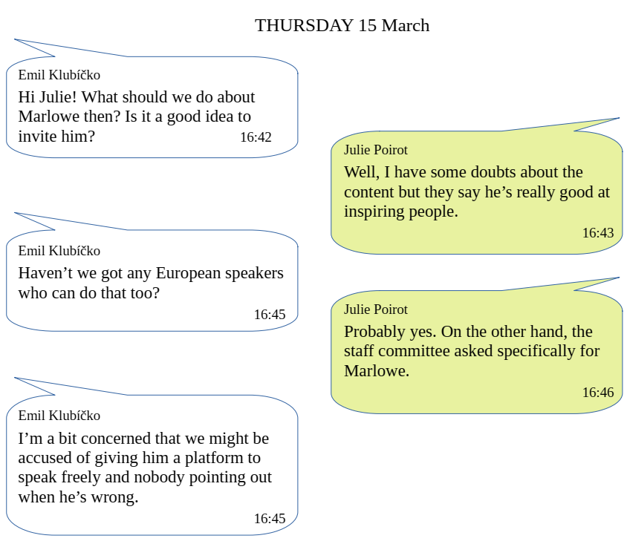

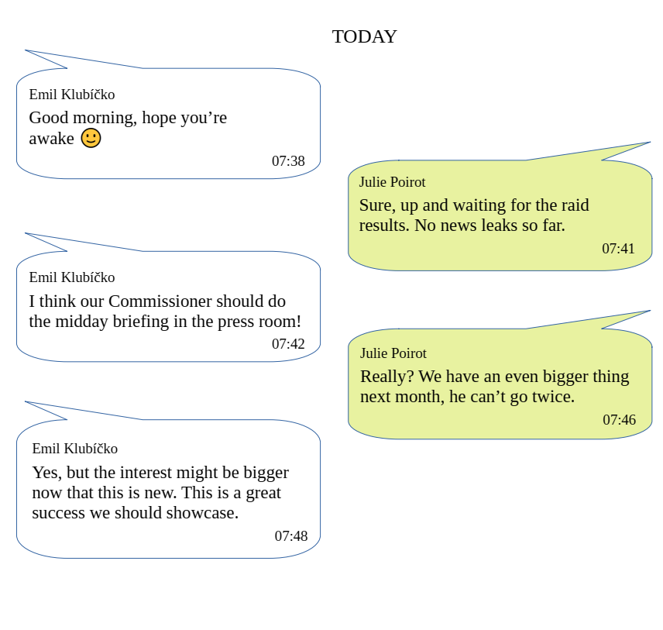

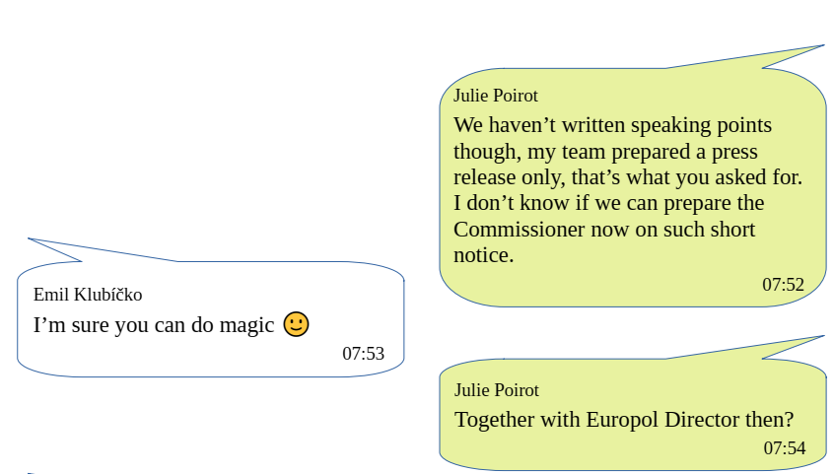

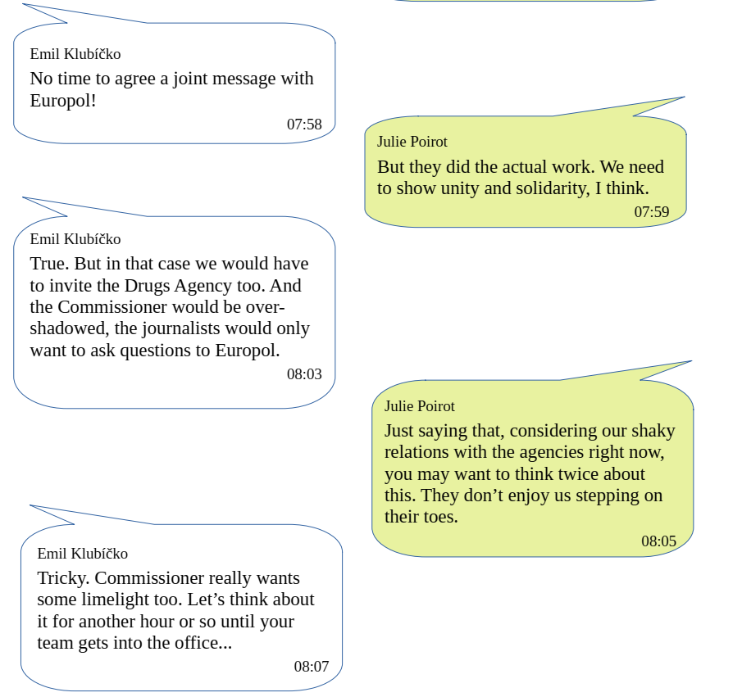

**Website 2**



| **DRUGS POLICY**  **Law and Order Department** |
| --- |

Drugs are a complex **social and health phenomenon that** **affects millions of people** in the EU. Illicit drugs can have tremendous negative consequences, not only for the people who use the drugs but also for their families and communities.

The use of drugs generates **enormous costs** for and harm to public health and safety, the environment and labour productivity. It also poses **security threats** linked to violence, crime and corruption.

The illicit drugs market is one of the major sources of income for **organised crime** groups in the European Union, and represents an estimated yearly retail value of at least €30 billion.

In the EU, as in many countries around the world, drug trafficking also affects **national stability and governance**.

**Coordination and cooperation**

The EU and its Member States have taken a number of strategic and operational measures to reduce drug supply and demand in Europe. They coordinate them through the **EU drugs strategy**.

The work and the strategy is implemented by national law enforcement bodies, in close cooperation with the EU Drugs Agency (*former* European Drugs Monitoring Centre) and the EU Agency for Law Enforcement Cooperation (Europol), as well as with international partners and civil society organisations.

**Measures and actions**

To reduce drug supply, the EU seeks to reduce profitability of drug-related trade and crime.

Measures in this area include the prevention of, dissuasion from and disruption of drug-related criminal activities, through judicial and law enforcement cooperation and intelligence. Confiscation of criminal assets, investigations and border management are important tools in the “war on drugs”.

Drugs-related health damage is also addressed under prevention, treatment and care services and harm reduction, primarily at national level.

## 

## **EU Drugs Strategy**

The Commission adopted the EU Drugs Strategy for the years 20XX-3 to 20XX+3.

The strategy aims to:

* protect and improve the well-being of society and of the individual
* protect and promote public health
* offer a high level of security and well-being for the general public

The strategy takes an evidence-based, integrated, balanced and multidisciplinary approach to the drugs phenomenon at national, EU and international level.

**E-mail 7**



**LOD**

| Subject: Mid-term evaluation  From: Petra Verhoeven, Administrator, Drugs Strategy Unit, LOD  To: LOD Senior Management Group  Date: 8 March 20XX  Dear all,  As requested, here is some information about the latest state of play.  Some main indicative mid-term evaluation results are as follows:   * Implementation of the Drugs Strategy has been slower than expected. This is largely because the resources are insufficient both in the Member States and in our agencies. The re-organisation of the monitoring centre into a proper agency also caused a certain delay (but this should now be caught up quickly as we are told the new organisation will be much more efficient than the old centre!). * We have not reached all targets, especially not in the area of “reducing supply” and the so-called “war on drugs” flagship. * The application of the latest tools/methods for sensing and tracking new chemical compounds has been helpful and will count as a major success of the strategy work. The new tools have helped authorities to find hidden drugs more easily and to detect a wider range of chemical drugs. This is useful as the drug producers keep changing the recipes to avoid detection and legal prosecution. The new tools also identify the new variants and with great accuracy. * The awareness-raising campaigns performed in the first half of the strategy period have been perceived positively by our focus groups. The most clicked item was the “most wanted profile gallery”, even though we barely did any promotion at all of that campaign (low-cost, high reach).   In response to the earlier senior management request for new ideas: we propose a “Police Erasmus” like the Erasmus exchange programme for students. We’re looking into ways to use EU funding to enable something similar among police officers. They could be sponsored to go work in other countries for half a year to get new inspiration and knowledge. Please let us know if you want us to pursue this idea and develop a full programme proposal.  With best regards,  Petra  Petra Verhoeven,  Administrator, Drugs Strategy Unit  Law and Order Department  European Commission |
| --- |

**Commission intranet entry**



**Intranet: press room information**

**What is a midday briefing?**

The European Commission holds a daily midday press briefing. It takes place every weekday in the Commission's press room. In this briefing, journalists may ask questions to the Commission officials on any topic. Presentations are delivered by the Commission Spokesperson on the topics of relevance for the day. If the topic is sensitive or of significant political weight, one or several Commissioners might attend and speak to it.

**What you need to prepare**

If your issues are likely to be commented on in the midday briefing, please make sure to send the Spokesperson service all latest updates and important facts and figures. The information should be provided in concise and easy-to-read bullet points with the most relevant aspects on top. Prepare your file as early as possible as the Spokesperson colleagues may need to get clarifications or additional information from you.

For technical files, your manager or you may be requested to attend the briefing room and be ready to answer more specific questions by journalists.

If a Commissioner participates in the midday briefing, please make sure to prepare speaking points and background briefing for them. Commissioner speakings must be approved by the Department hierarchy and the Commissioner’s cabinet member in charge of the file.